SIMATSENGINEERING C03ASSESSMENTTOOL1
COURSE CODE: CSA1610 COURSE NAME: DWDM
D. BHAVITHA(192511152)

EXPERIMENTS

Q1RCodeforCovarianceandCorrelation: CODE:
#Dataforphotographpreferences preferences<-data.frame(
Age=c("5-6","7-8","9-10"),
A=c(18,2,20),
B=c(22,28,10),
C=c(20,40,40)
)

#SamplecovariancebetweenBandC cov(preferences$B,preferences$C)

#Samplecovariancematrixforallpreferences(A,B,C) cov(preferences[,2:4])

#SamplecorrelationbetweenBandC cor(preferences$B,preferences$C)

#Samplecorrelationmatrixforallpreferences cor(preferences[,2:4])

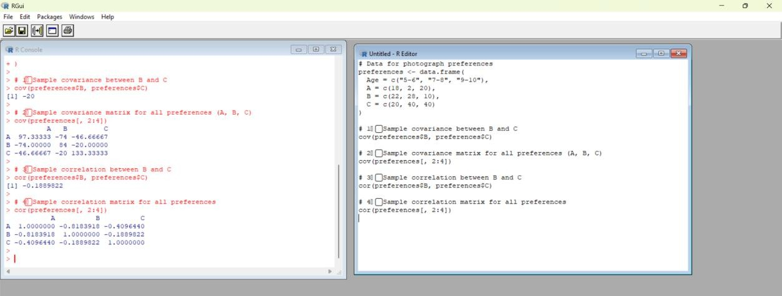

Q2RCodeforBoxplotandOutlierDetection CODE:
#Data:Pointsscoredbyplayers
points<-c(12,15,14,10,18,20,22,13,11,35,16,17,19,21,23)

#Createaboxplot boxplot(points,
main="TennisPlayersPointsDistribution", ylab = "Points Scored",
col = "lightblue", border="darkblue")

#Identifyoutliers
outliers<-boxplot.stats(points)$out outliers

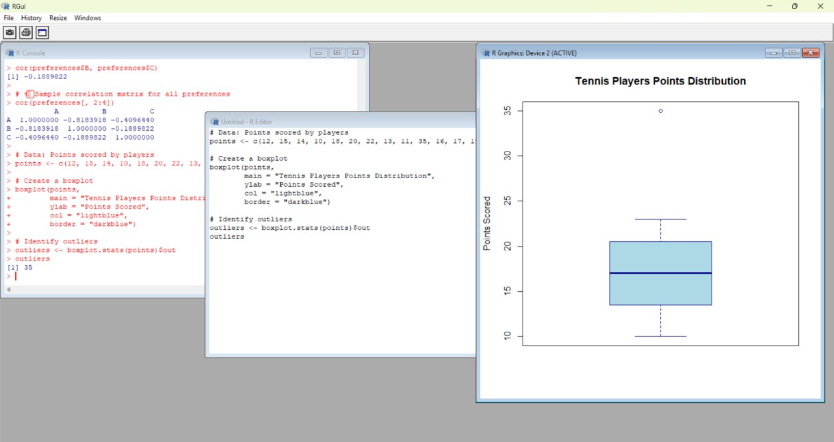

Q3RCodeforDecisionTreeClassifier CODE:
#Installandloadrequiredpackages #install.packages("rpart")
#install.packages("rpart.plot") library(rpart)
library(rpart.plot)

#Dataset
loan_data<-data.frame(
Age=c("young","young","middle","old","old","old","middle","young","young","old", "middle","middle","old","young","middle"),
Income=c("high","high","high","medium","low","low","low","medium","low","medium", "medium","high","medium","medium","low"),
Employment=c("employed","self-
employed","employed","employed","unemployed","self-employed",
"unemployed","employed","unemployed","self-employed","employed","self-employed",

"unemployed","self-employed","employed"),
Credit = c("good","average","good","good","poor","average","poor","average","poor","good", "average","good","poor","average","poor"),
Loan=c("yes","yes","yes","yes","no","no","no","yes","no","yes","yes","yes","no","yes","no")
)

#BuildDecisionTree
tree<-rpart(Loan~Age+Income+Employment+Credit,data=loan_data,method= "class")

#PlottheDecisionTree
rpart.plot(tree,main="LoanApprovalDecisionTree",type=3,extra=102)
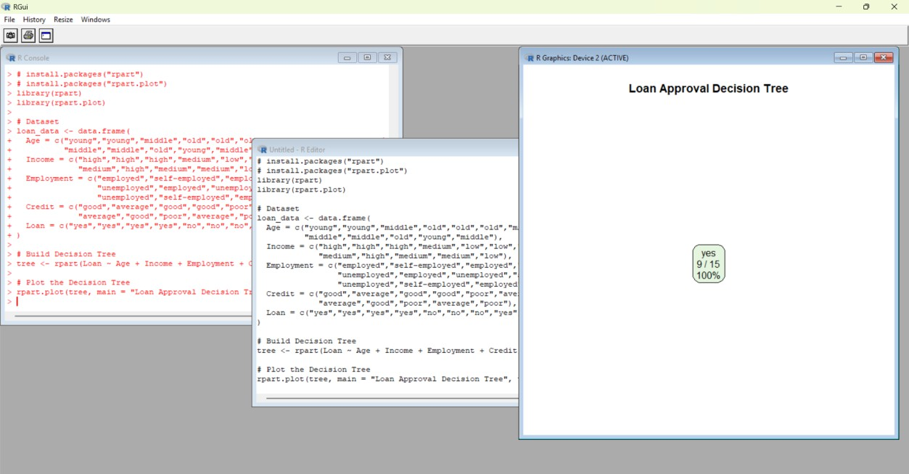

Q4RCodeforMean,Median,Range,andBoxplot CODE:
#DataforClassAandClassB
classA<-c(76,35,47,64,95,66,89,36,84)
classB<-c(51,56,84,60,59,70,63,66,50)

# Mean, Median, Range meanA <- mean(classA) medianA<-median(classA) rangeA <- range(classA)

meanB <- mean(classB) medianB<-median(classB) rangeB <- range(classB)

#Displayresults
meanA;medianA;rangeA meanB;medianB;rangeB

#Boxplotcomparison boxplot(classA,classB,
names=c("ClassA","ClassB"),
main="Year9ExamResultsComparison", col=c("lightgreen","lightpink"),
ylab="Scores")

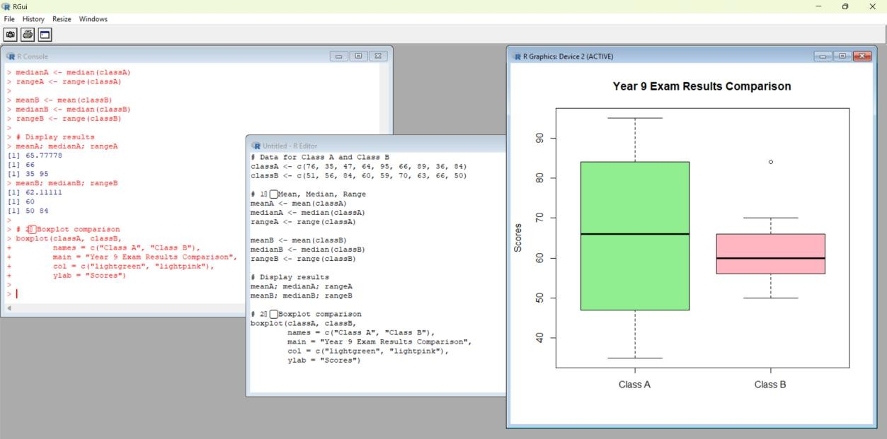

Q5RCodeforStatisticalAnalysis CODE:
#Data
age<-c(23,23,27,27,39,41,47,49,50,52,54,54,56,57,58,58,60,61)
fat<-c(9.5,26.5,7.8,17.8,31.4,25.9,27.4,27.2,31.2,34.6,42.5,28.8,33.4,30.2,
34.1,32.9,41.2,35.7)

#(a)Mean,Median,StandardDeviation mean(age);median(age);sd(age) mean(fat);median(fat);sd(fat)

#(b)Boxplots
par(mfrow=c(1,2))#Displayside-by-side
boxplot(age,main="BoxplotofAge",col="lightblue",ylab="Age")
boxplot(fat,main="BoxplotofBodyFat%",col="lightgreen",ylab="%Fat")

#(c)ScatterPlotandQ-QPlot par(mfrow=c(1,2))

plot(age,fat,main="ScatterPlot:AgevsBodyFat",xlab="Age",ylab="%Fat",pch=19, col = "darkblue")
qqplot(age,fat,main="Q-QPlot:AgevsBodyFat",xlab="AgeQuantiles",ylab="Body FatQuantiles",col="purple")
